# JS Advanced Retake - 08 August 2019

Exam problems for the [JavaScript Essentials” course @ SoftUni](https://softuni.bg/courses/js-essentials). Submit your solutions in the SoftUni Judge system at <https://judge.softuni.bg/Contests/Practice/Index/1772#0>.

## Problem 1. BookUni

### Use the provided skeleton to solve this problem.

### You can't, and you have no permission to change directly the given html code (index.html file).

### Your Task

**Write the** **missing JavaScript code** to make the **Book Store (BookUni)** work as expected:

* When **all fields (title, year and price)** are **filled with correct input**
  + **Title** is **non**-**empty** **strings**
  + **Year** and **Price** need to be **positive** **numbers**
* Upon pressing the **[Add new book]** **button**, a new book should appear in the bookshelf section. Create new **div** **element** with **class** **book** (for every created book) which hold:
  + **paragraph** with text content of the given book title and the given book year in format: **"{bookTitle} [{bookYear}]"**
  + **button** with text content "**Buy it only for {bookPrice} BGN**" and **functionality** when is being clicked the **current book should be removed** from the current section and the **total store profit** is **increased** with the given **book price**.
  + (**only applies to new books**) **button** with text content "**Move to old section**" which have the **functionality** when is being clicked the current book should be **moved** from the new books section to the **old books section**.

### Constraints

Every price should be **rounded** to the **second** **decimal** **part (**a.k.a **toFixed(2)**)

Every **old book price** has **15% discount** from the **initial value** (When being **created** into the **old** **books** **sections** or being **moved** from the new books section to **the old books section**)

Each **book's year** **equal** or **higher** than **2000** is consider for a **new book.**

### Submission

Submit only yours **solve()** function.

### Examples

#### Create a new book

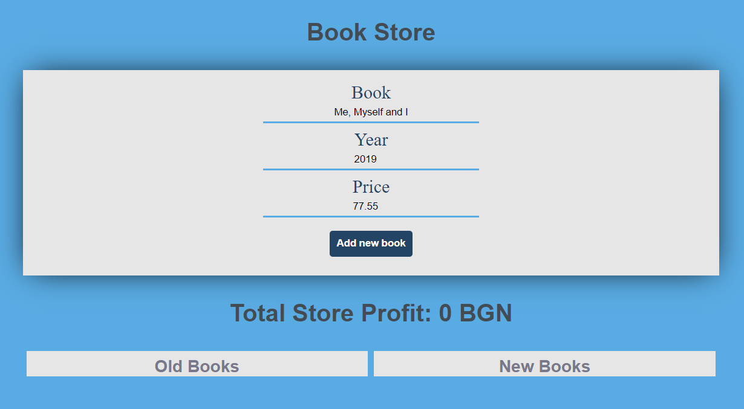

**After** we hit the **[Add]** **button**

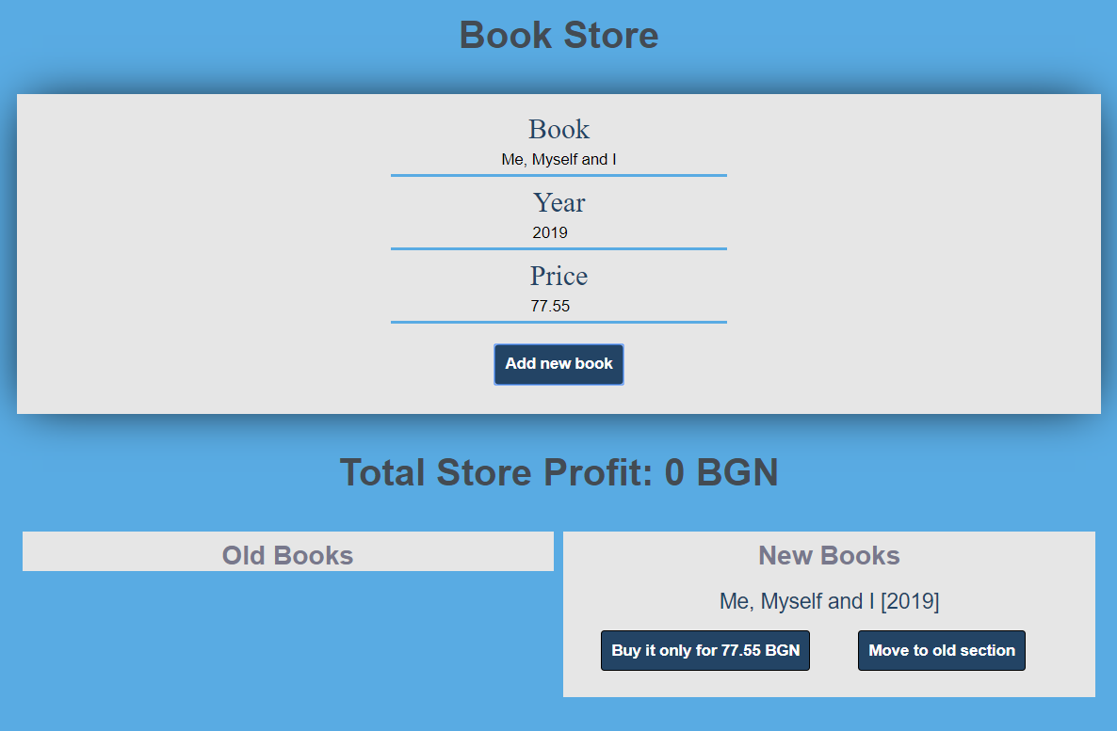

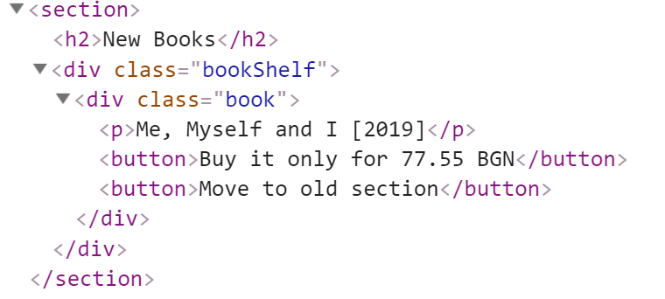

#### Create an old book

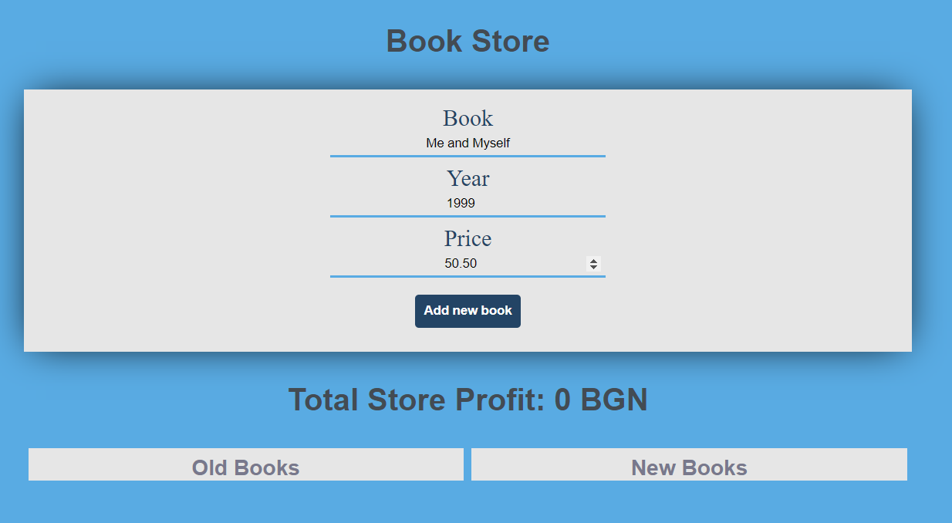

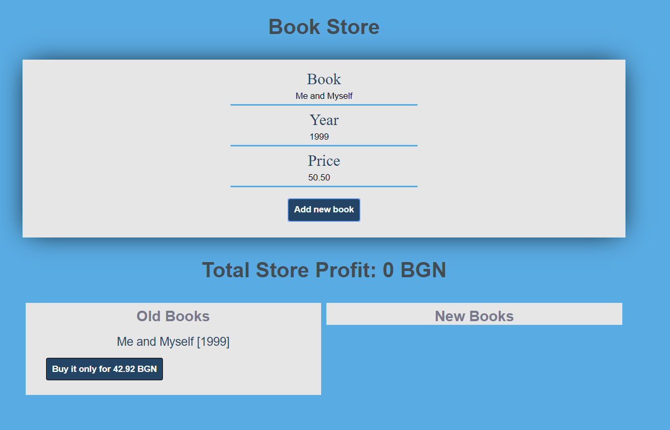

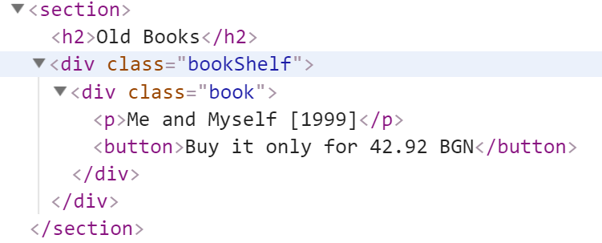

#### Buy a book

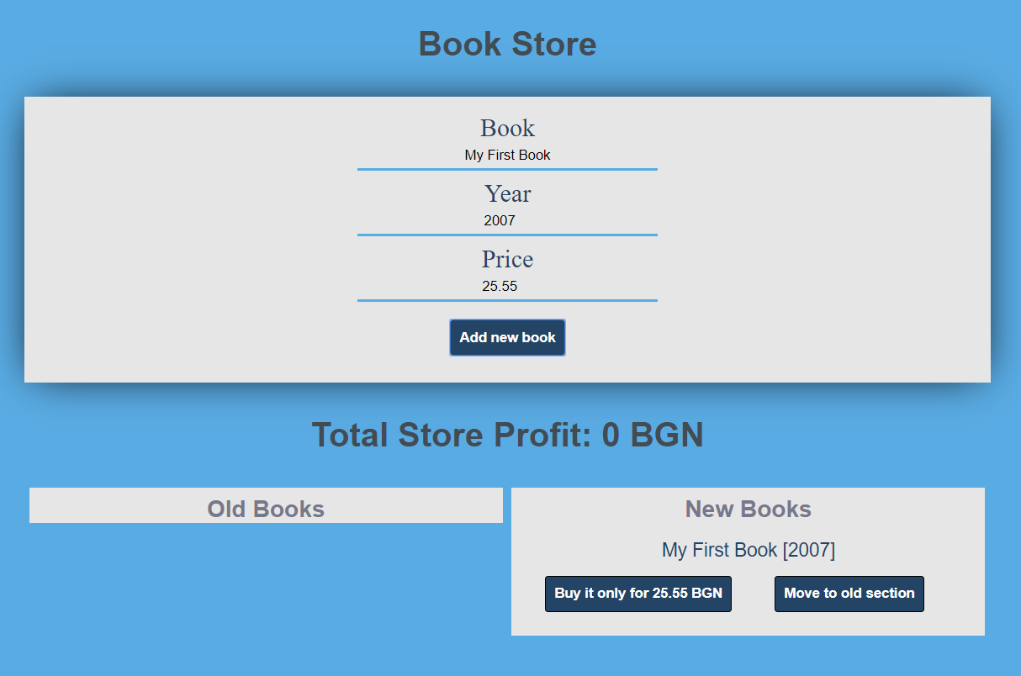

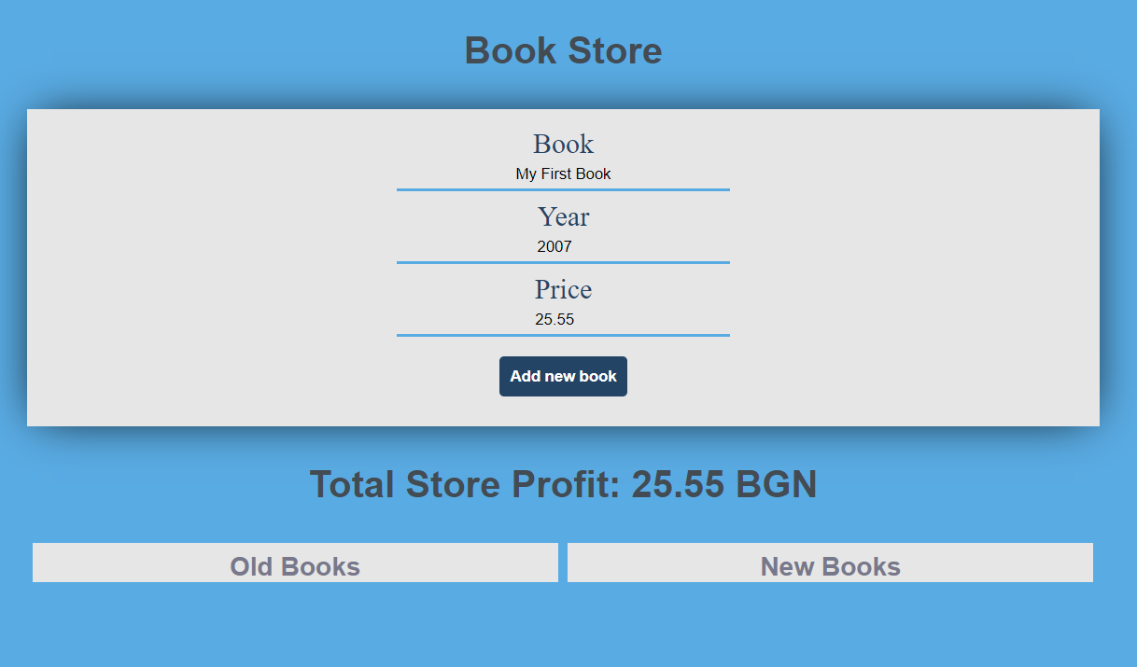

#### Move new book to the old section

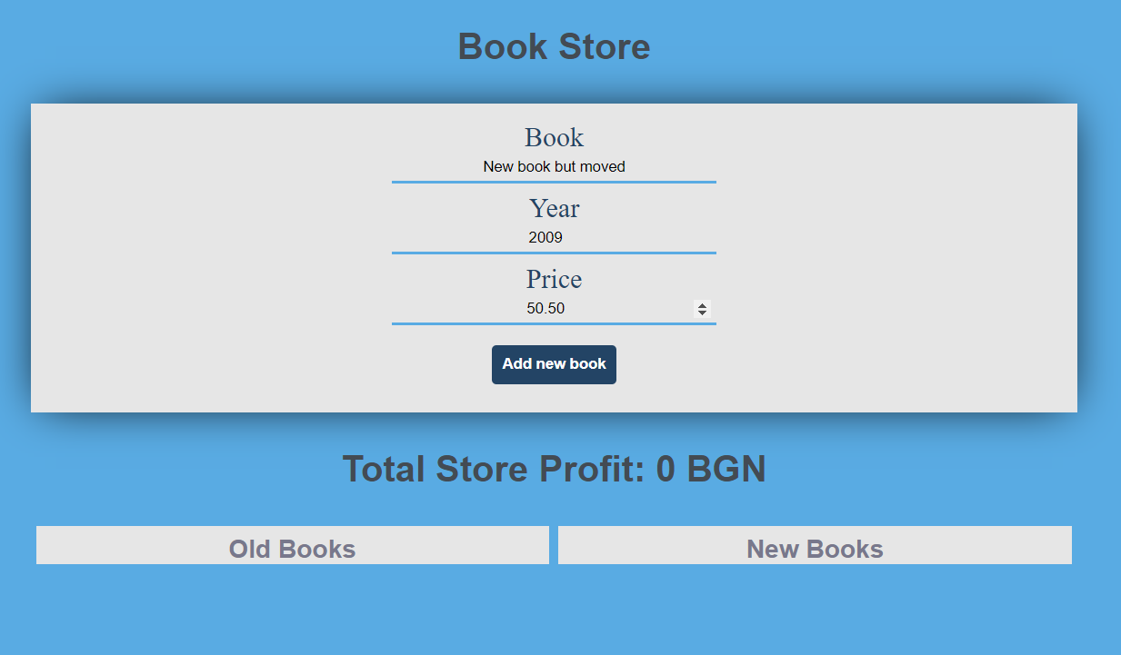

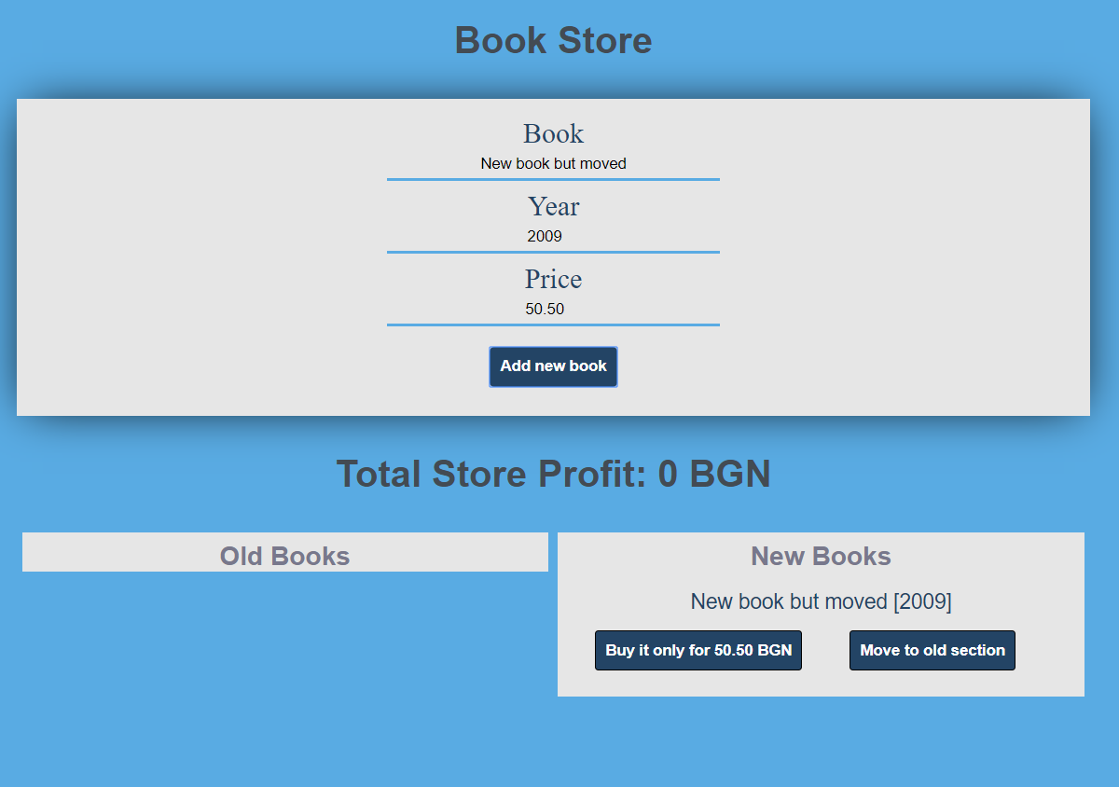

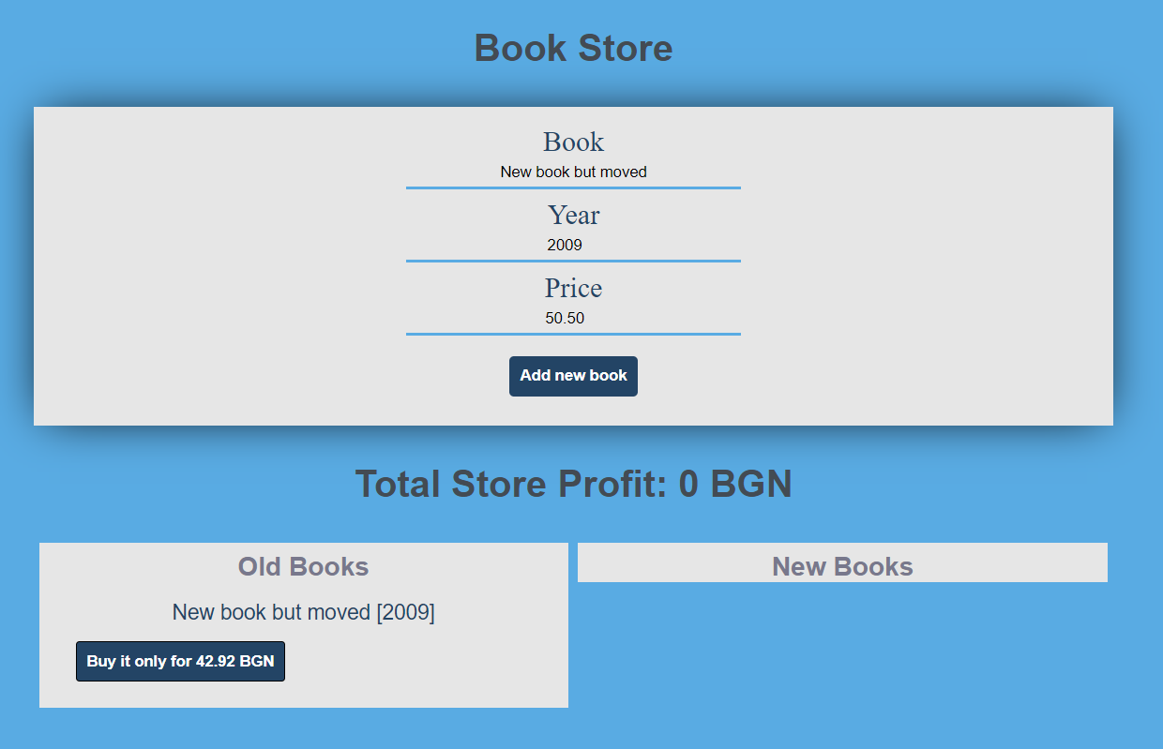

*GOOD LUCK… c(:*